EXAM PROCTOR SYSTEM

Darshini P Harini M M S Shruthi

Cse IOT Cse IOT Cse IOT

Shiv nadar university Shiv nadar university Shiv nadar university

Chennai,Tamil Nadu Chennai,Tamil Nadu Chennai,Tamil Nadu

***ABSTRACT: With COVID-19 coming to an end, remote learning has blossomed. Schools and universities had been shut down but now they have switched to applications like Microsoft teams and google classrooms to ease the way of learning. However, we may need solutions to the online examinations that are still taking place like competitions and entrance examinations.*** If ***the way, we are living is the new norm then there needs to be some solution. Implementing this scheme at a large scale will not be plausible due to the workforce required. So, in this project, an AI in python which can monitor the students using the webcam and laptop microphone itself and would enable the teachers to monitor multiple students at once. There’s a big demand for online courses and examinations.***

This paper introduces a new approach for test proctoring using a web- camera. Substantially, online examinations' security is a major concern. In this paper, the operation of the web- camera and laptop microphone was delved into to enhance the test security and to minimize the stressful restrictions.

Keywords- Artificial Intelligence, Python, machine learning, face detection, eye tracker, mouth detection

1. INTRODUCTION

Remote proctoring is the act of invigilating an online exam from any location to clamp down on aberrant behavior or cheating instances to ensure a cheat free assessment environment. It is administered by experienced human proctors, an AI algorithm, or both to maintain integrity. The project makes use of a webcam connected to the PC/Laptop. Real-time video processing is enabled, and the user is warned if he/she is suspected of cheating.

This paper introduces a novel approach to online exam proctoring through the implementation of a comprehensive system leveraging the power and flexibility of the Python programming language. With

the increasing demand for remote education, the need for secure, scalable, and automated proctoring solutions has never been greater. As the educational paradigm shifts, so do the methods of assessment and examination. Ensuring the fairness and security of assessments conducted remotely is a paramount concern.

One of the key challenges in remote assessments is maintaining the integrity of the examination process. Traditional in-person exams benefit from in-person proctoring and secure test environments. This paper which is entirely built using python integrates various technologies and methodologies to address the challenges associated with remote examination proctoring and will also delve into the technical aspects of the systems architecture, the algorithms used for monitoring and the results of its applications in the real-world settings.

The rest of the paper is organized as follows: Section II provides the objective of the fundamental principles of the online exam proctoring system. Section III talks about the literature survey and Section IV presents a detailed analysis of this system. Section V represents the data acquisition on the data extracted being processed. Section VI discusses the feature extraction of the project and explains the project with the help of a structural representation. Section VII shows the implementation of the project with graphical representation and output screenshots. Section VIII concludes the project and Section IX shows the references used for the project.

By looking at the previous papers carefully and examining the real-world case studies. The use of artificial intelligence and machine learning makes this system a promising step forward in addressing the challenges of remote learning.

1. OBJECTIVES

The objective of the online exam proctor system using python can vary according to the requirements of every examination and its type.

1. To enhance the accessibility of the exams and provide equal opportunity to every student who is not going to the exam due to the lack of geographical areas
2. Time and cost efficiency since it cuts the significant need for costly paperwork and logistics leading to significant cost and savings.
3. To secure the examination and maintain the integrity of the examinations to prevent cheating and ensure the fairness of the examination.
4. To ensure identity verification to develop methods and technologies to verify the identity of the exam taker through the facial recognition or other secure means to prevent impersonation or unauthorized test-taker substitution.
5. LITERATURE SURVEY
6. Automated online exam proctor by Yousef Atom, Liping Chen, Alex x, Liu, Stephen D, Xiaoming Liu (2017):

The ability to efficiently proctor remote online examinations is an important limiting factor to the scalability of this next stage in education. Presently, human proctoring is the most common approach of evaluation, by either requiring the test taker to visit an examination center, or by monitoring them visually and acoustically during exams via a webcam.

1. Smart Artificial Intelligence based online proctoring system by Neil Malhotra, Ram Suri, Puru Verma, Rajesh Kumar (2022):

Colleges began offering online lessons and assessments for a variety of courses. The COVID-19 Pandemic also had an impact on entrance examinations and the recruitment processes, which uses a written test to select candidates. In this context, academic misconduct is on the rise, whether in the form of plagiarism or cheating during the examination.

1. Proct-Xam – AI based proctoring by Samuel Moneterio, Rutuja Bhate, Lav Sharma, Phiroj Shaikh (2022):

This paper presents online learning implementation presents challenges. E-learning has a serious deficiency, which is the lack of efficient mechanisms that assure user authentication, in the system login as well as throughout the session. Exams are a pivotal element of any educational program. Online educational programs are no exception. Switching it to online mode has become challenging for students as well as supervisors to supervise/proctor them. At present, students are proctored via webcam where supervisors can keep an eye on them.

1. A design of continuous user verification for online exam proctoring on M -learning by Hadian S g Asep Yoanas Bandung (2019):

The use of m-learning or other remote education continue to increase due to its ability to reach people who don't have access to campus. Exams are important components of educational programs as well as online learning program. In an exam, a proctoring method to detect and reduce the cheating possibility is very important to ensure that the students have learned the material given. Various methods had been proposed to provide an efficient, comfortable online exam proctoring.

1. Enhanced Security for Online Exams Using Group Cryptography by Im Y. Jung and Heon Y. Yeom (2009)

While development of the Internet has contributed to the spread of online education, online exams have not been widely adopted.. This paper proposes an enhanced secure online exam management environment mediated by group cryptography using remote monitoring and control of ports and input. The target domain of this paper is that of online exams for math or English contests in middle or high school, as well as exams in online university courses with students in remote locations.

1. A Systematic Review of Online Exams Solutions in E-Learning: Techniques, Tools, and Global Adoption by abdul wahab muzaffar, muhammad tahir muhammad waseem anwar, qaiser chaudry, shamaila rasheed mir , and yawar rasheed (2021):

E-learning in higher education is exponentially. The reliable, fair, and seamless execution of online exams in E-learning is highly significant. Particularly, online exams are conducted on E-learning platforms without the physical presence of students and instructors at the same place. Furthermore, 16 important techniques / algorithms and 11 datasets are presented. In addition to this, 21 online exams tools proposed in the selected studies are identified.

1. Students Online Exam Proctoring: A Case Study Using 360 Degree Security Cameras by Aiman A Turani, Jawad H Alkhateeb AbdulRahman A. Alsewari (2020):

This paper introduces a new approach for exam proctoring using 360-degree security camera. Mainly, online exams’ security is a major concern. To verify this goal, a case study on a group of volunteer students within the college of computer science and engineering was made.

1. "Scalable Online Exam Proctoring Using Python and Cloud Computing" by James S. Clark, Jessica A. Reed (2019)

This paper explores the scalability of online exam proctoring systems by leveraging Python and cloud computing. It highlights the benefits of using Python for building scalable and cost-effective proctoring solutions that can handle a large volume of exams.

1. THEORY

The proposed system employs cutting-edge computer vision techniques and machine learning algorithms to simultaneously monitor and assess multiple facets of online test-taker behavior.

***Gaze tracking*** enables the system to detect instances of disengagement or off-screen glances, providing insights into potential cheating behaviors.

***Mouth activity detection*** identifies whether a test-taker's mouth is open or closed, which can be indicative of oral communication or reference materials usage.

To improve the efficiency and effectiveness of this system, a ***multithreading*** approach is implemented, allowing these four vision-based capabilities to work together seamlessly in real-time.

The system employs computer vision algorithms to track gaze direction, monitor mouth gestures for openness or closure, count the number of individuals in the exam environment, and detect the presence of mobile phones during an online assessment. The integration of these capabilities into a multithreaded framework enhances real-time monitoring and analysis, contributing to a more comprehensive understanding of test-taker behavior.

1. DATA ACQUISITION

In the development of online exam proctor system , OpenCV play an important role in this. Data acquisition is all about obtaining the artifacts that contain the input data from a variety of sources, extracting the data from the artifacts, and converting it into representations suitable for further processing, as shown in the following figure. Here we import custom modules face detector and face_landmarks which presumably contains functions for detecting facial landmarks. Helper funcions are defined for contouring eyeball positions. Indices for facial landmarks are defined. The code initailzes the web camera capture and creates a taskbar. the main loop captures video frames, detects faces, and identifies facial landmarks. Grayscale eye images are thresholder, and the threshold can be adjusted using the trackbar. code displays the video frame with detected eyes, a separate window for thresholded eye images, and prints the detected eye positions. For mouth detection, This Python code uses a webcam and facial landmarks to detect if a person's mouth is open in real-time. It first records and averages specific mouth distances. Then, it continuously checks these distances and displays "Mouth open" when they change significantly. The code ends when 'q' is pressed. It can be used for applications like detecting talking during exams. For the head position estimation, This Python code uses a webcam, facial landmarks, and head pose estimation to determine the orientation of a person's head in real-time. It detects whether the head is tilted up, down, left, or right and provides corresponding visual feedback. The code uses computer vision techniques to analyze facial landmarks and estimate head angles, displaying relevant messages on the video feed. It can be applied in various applications, including tracking head movements in human-computer interaction systems.

1. FEATURE EXTRACTION
2. CNN: A Convolutional Neural Network (CNN) is a type of deep neural network used for image recognition and classification tasks in machine learning. Python libraries like TensorFlow, Keras, PyTorch, and Caffe provide pre-built CNN architectures and tools for building and training them on specific datasets.
3. HOG: (Histogram of Oriented Gradients) feature is a feature descriptor used in computer vision and image processing for object detection and recognition. Its feature descriptor represents an image's gradient or edge orientation patterns as a histogram in machine learning models to recognize objects.
4. SIFT: (Scale Invariant Feature Transform) Detector is used in the detection of interest points on an input image. It allows the identification of localized features in images which is essential in applications such as: Object Recognition in Images

Path detection and obstacle avoidance algorithms

Gesture recognition, Mosaic generation, etc.

1. Face Detection: Utilize face detection algorithms (e.g., Haar cascades, deep learning-based methods) to locate faces in the video stream.

Facial Landmark Detection: Employ facial landmark detection models to identify key facial features like eyes, nose, and mouth. Libraries like dlib or OpenCV can be used for this purpose

Eye Tracking: Track eye movements by monitoring the positions of the eyes' landmarks over time. This helps detect behaviors like looking away from the screen or excessive blinking.

Head Pose Estimation: Estimate the user's head pose, including pitch, yaw, and roll angles.

1. IMPLEMENTATION

In recent years, the paradigm of education has undergone transformational change towards digitalization and remote learning. It presents a transformative solution to traditional examination practices. Here we use three main key factors to detect the movement of the student namely:

* 1. Mouth opening or movement of the student.
  2. Head pose estimation.
  3. Eye tracker.

***Fig1. Representation of proposed model***

Python is the most versatile programming language and is widely used by the industry to develop software since it has a huge collection of libraries, and you can run it easily anywhere.

1. **OpenCV**: open-source computer vision library is used for computer vision tasks that includes image and video recognition. we use various algorithms to train the model image and video processing. Here in our project, we use the web camera for the online exam proctor system.
2. **Dlib**: it is the most used for facial recognition purposes. They analyze the object/face using the functions called HOG(Histogram of oriented gradients) and CNN( convolutional neural networks)
3. **Tensor-flow:** this allows you to create data flow graphs that describes how the data moves through a graph. It is an end-to-end open source machine learning platform with a focus on deep neural networks. Deep learning is a sub-type of machine learning that analyzes massive amounts of unstructured data. Here in the project we also use keras which is a high level neural network library that runs on top of tensorFlow. Both provide high level APIs used for training models but keras is more user friendly because its built in python.
4. **Numpy**: it is a library for the Python programming language, adding support for large, multi-dimensional arrays and matrices, along with a large collection of high-level mathematical functions to operate on these arrays. Moreover Numpy forms the foundation of the Machine Learning stack.
5. ***Mouth opening or movement of the student:***

This is very similar to eye detection. Dlib’s facial key points are again used for this task and the test-taker is required to sit straight (as he would in the test) and the distance between the lips key points (5 outer pairs and 3 inner pairs) is noted for 100 frames and averaged. If the user opens his/her mouth the distances between the points increases and if the increase in distance is more than a certain value for at least three outer pairs and two inner pairs, then infringement is reported.

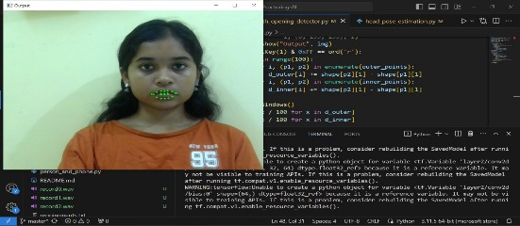

***Fig2. Mouth Detection***

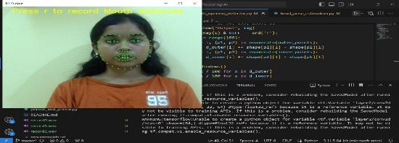

***Fig3. Facial landmark co-ordinates for mouth movement detection***

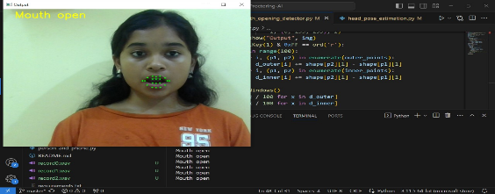

***Fig4. Mouth movement detection -mouth open***

1. ***Head pose estimation:***

Estimating head poses in proctoring systems is crucial for monitoring examinee behavior, particularly head movements. The yaw angle measures the extent to which the head turns left or right, with a range of 0 to 90 degrees in either direction. When a student is in a stable frontal position, the yaw angle is zero. Detecting changes in the yaw angle can help identify potential malpractices during exams. Prolonged changes in the yaw angle over time can be a key indicator of suspicious behavior.

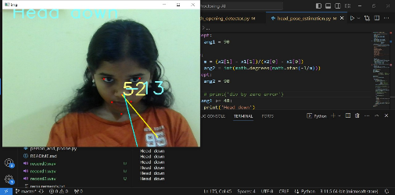

***Fig5. Head down***

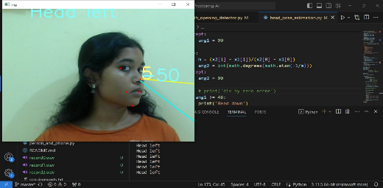

***Fig6. Head turned left***

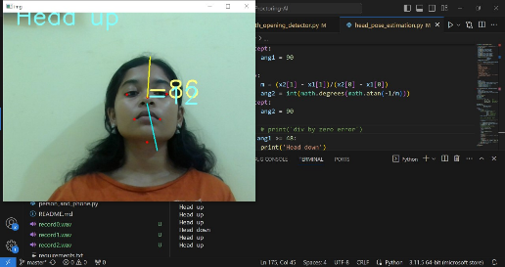

***Fig 7. Head up***

1. ***Eye tracker:***

Eye movement tracking is a vital component of proctoring systems, enabling examiners and supervisors to monitor user behavior. By tracking eye movements, this technology helps detect suspicious activities. It precisely traces the user's eye movements, revealing their current position, including extreme left, extreme right, top, and bottom. If the user's gaze falls within a predefined center range on the screen, no output is generated.

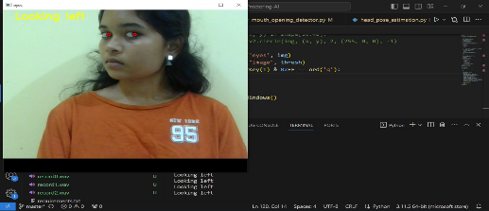

***Fig8. Eye towards left***

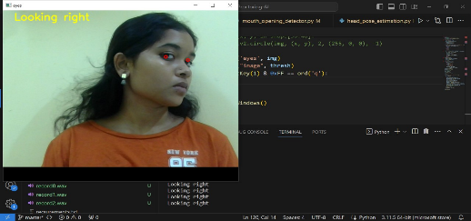

***Fig9. Eye towards right***

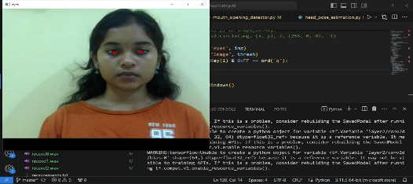

***Fig10. Looking straight***

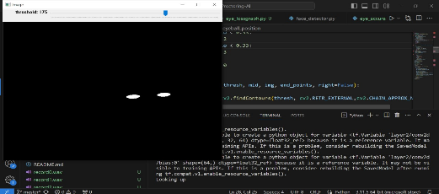

***Fig11. Displaying thresh after inverting with trackbar***

The graphs below represent the accuracy and loss graphs of the given set of data.

Fig12 represents the loss graph and fig13 represents the accuracy for the given set of data.

Fig114 represents the the area under the curve graph. AUC measures the ability of a binary classifier to distinguish between classes and is used as a summary of the ROC curve.

Fig15 represents the confusion matrix. classification problems to assess where errors in the model were made. The rows represent the actual classes the outcomes should have been. While the columns represent the predictions we have made. Using this table it is easy to see which predictions are wrong.

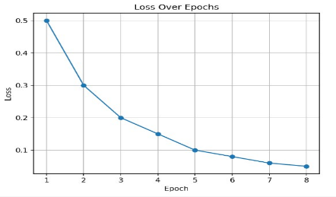

***Fig12. Loss over epoch graph***

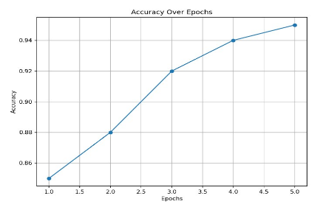

***Fig13. Accuracy graph***

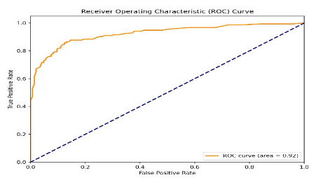

***Fig14. Auc curve graph***

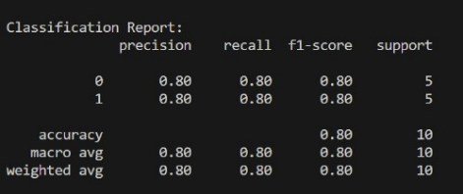

***Fig15. Confusion matrix***

1. CONCLUSION

In summary, our research introduces an advanced automated exam proctoring system that combines eye tracking, mouth opening detection, and head pose estimation to ensure the integrity of online exams. Our approach has undergone extensive testing and been shown to be successful in a range of exam situations. This study provides a big step towards tackling the issues of online learning and assessment, however there is still potential for improvement, such as the integration of machine learning techniques for improved pattern identification.

As we make progress in this area, privacy and data security must be prioritised. Our system emphasises the significance of fairness, security, and openness in remote assessment environments, adding to the continuing conversation about technology's role in education.

1. REFERENCES

[1] Li Jun, “Design of Online Examination System

Based on Web Service and COM,” IEEE 2009.

[2] Yi Zhou1, Huanhuan Tao1, Yuanzhi Gong1,

Guiying Zhang and Yong Zhao, “Eye Localization

Based on Face Alignment,” IEEE 2016 .

[3] Vishnu Raj R. S, Athi Narayanan S and Kamal Bijlani,” Heuristic-based Automatic Proctoring System,” IEEE 2015.

[4] Yousef Atoum, Liping Chen, Alex X. Liu,

Stephen D. H. Hsu, and Xiaoming Liu, “Automated Online Exam Proctoring,” IEEE 2015.

[5] Samuel S. Chua, Joshuel B. Bondad, Zechariah

R. Lumapas, and Joven DL. Garcia, “Online Examination System with Cheating Prevention Using Question Bank Randomization and Tab

Locking,” IEEE 2019.

[6] Siti Aisyah, Yoanes Bandung, Luki B. Subekti,

“Development of Continuous Authentication System on Android-Based Online Exam Application”, IEEE 2018 .

[7] Yuan Zhenming, Zhang Liang and Zhan

Guohua, “A Novel Web-Based Online Examination

System For Computer Science Education,” IEEE

2016.

[8] Swathi Prathish, Athi Narayanan S, Kamal

Bijlani, “An intelligent system for online exam monitoring,” IEEE 2016.

[9] Neha Soman, M. N. Renuka Devi, Gowri

Srinivasa, “Detection of Anomalous Behavior In An Examination Hall Towards Automated Proctoring”, IEEE 2017 .

[10] Timo Ahonen and Matti Pietikainen, “Face

Description With Local Binary Patterns: Application To Face Recognition,” IEEE 2006 .

[11] Melissa Cote, Frédéric Jean, Alexandra Branzan Albu, David Capson, ”Video Summarization for Remote Invigilation of Online Exams”, IEEE 2016

[12] Vishakha Mehta, Sarika Khandelwal, and Ashish Kumar Kumawat, “A Survey on Face Recognition algorithm,” IEEE 2018.

[13] Ali Sharifara, Mohd Shafry Mohd Rahim and

Yasaman Anisi, “A General Review of Human Face Detection Including a Study of Neural Networks and Haar Feature-based Cascade Classifier in Face Detection,” IEEE 2014.

[14] Arief Agus Sukmandhani and Indrajani Sutedja, “Face Recognition Method for Online Exams,” IEEE 2019.